Project Design Phase-II
Data Flow Diagram & User Stories

Date | 15 February 2026
Team ID | LTVIP2026TMIDS81213
Project Name | AutoSage App Using Gemini Flash
Maximum Marks | 4 Marks

Data Flow Diagrams:
A Data Flow Diagram (DFD) is a traditional visual representation of the information flows within a system. A neat and clear DFD can depict the right amount of the system requirement graphically. It shows how data enters and leaves the system, what changes the information, and where data is stored.

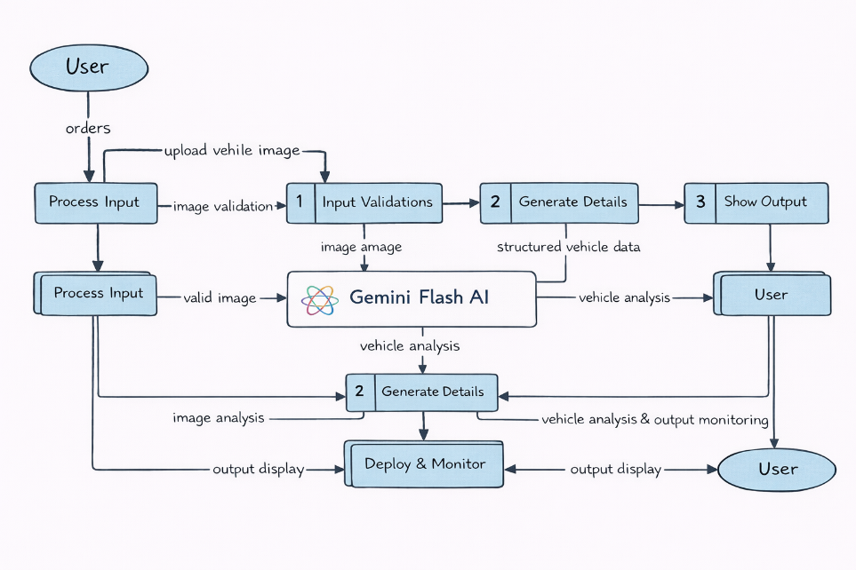

User Stories
Use the below template to list all the user stories for the product.
User Type | Functional Requirement (Epic) | User Story Number | User Story / Task | Acceptance criteria | Priority | Release
Customer (Mobile user) | Registration | USN-1 | As a user, I can register for the AutoSage application using email and password | User can successfully create account and access dashboard. | High | Sprint-1
 |  | USN-2 | As a user, I will receive confirmation email once I have registered for the application | User receives confirmation email and activates account. | High | Sprint-1
 |  | USN-3 | As a user, I can register using google account. | User can register and access dashboard via Google login. | Medium | Sprint-2
 | Login | USN-4 | As a user, I can log into the application by entering email & password | User can successfully log in and access dashboard. | High | Sprint-1
 | Dashboard | USN-5 | As a user, I can upload a vehicle image for analysis. | System accepts valid image formats and processes the image. | High | Sprint-1
 |  | USN-6 | As a user, I can enter a vehicle query(brand/model) manually | System accepts input and returns vehicle details. | High | Sprint-1
 | Vehicle Analysis | USN-7 | As a user, I want the system to analyze vehicle images using Gemini Flash AI | System extracts and displays vehicle details (brand, mileage, fuel type, price). | High | Sprint-2
 |  | USN-8 | As a user, I want structured vehicle details to be displayed clearly. | Vehicle details appear in organized readable format. | High | Sprint-1

